<https://www.hostinger.com/tutorials/what-is-a-url>

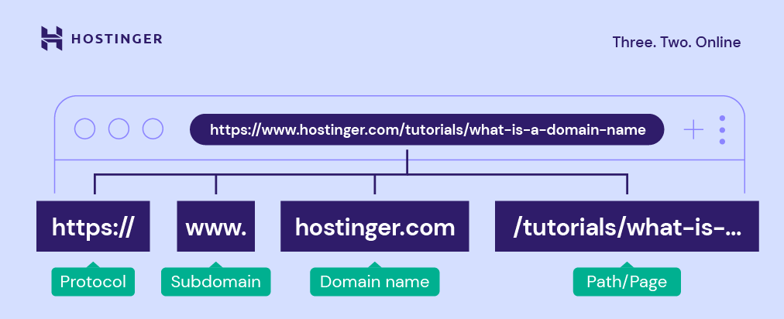

**HTTP or HTTPS**

[**HTTP (Hypertext Transfer Protocol) and HTTPS (Hypertext Transfer Protocol Secure)**](https://www.hostinger.com/tutorials/http-vs-https) are network communication protocols between web servers and web browsers. They transmit messages, retrieve information through the domain name system (DNS), and return it to the browser.

The difference between HTTP and HTTPS is that the latter encrypts the data transmission process. This security protocol protects a website better and is an essential factor in improving ranking on search results.

Another difference is that HTTPS uses the Transmission Control Protocol/Internet Protocol (TCP/IP) port number 443 encrypted by Transport Layer Security (TLS). Meanwhile, an HTTP URL uses TCP/IP port number 80.

**Important!** Web browsers can also process other protocols, including FTP and mailto. The former allows file sharing between different web hosts, either local or remote. The latter directs users to a specific email address.

**www (Subdomain)**

A [**subdomain**](https://www.hostinger.com/tutorials/what-are-subdomains) consists of any words or phrases that come before a URL’s first dot. Referring to the world wide web, **www** is the most common type. It indicates that a website is accessible through the internet and uses HTTP to communicate.

Furthermore, site owners can use any word as a subdomain for website organization purposes as it points to a specific directory from the primary domain. Some of the most popular options are “blog” and “news.”

For example, while

hostinger.com

 uses www, the subdomain for our **Knowledge Base** page is “support.” Hence, the

support.hostinger.com

 URL.

**Domain Name**

A [**domain name is**](https://www.hostinger.com/tutorials/what-is-a-domain-name) what users type into their browser’s address bar to reach a website. It consists of a site name and an extension, for example,

hostinger.com.

Every name is unique, and they represent their corresponding IP addresses. This unique IP address points to the website’s server. In other words, it helps users access websites easily.

**Domain Extension**

Also called a [**top-level domain (TLD)**](https://www.hostinger.com/tutorials/what-is-tld), is the bit following a website name. Used for around [**53%**](https://w3techs.com/technologies/overview/top_level_domain) of all websites, **.com**is the most popular extension.

Here are types of TLD extensions to consider using:

* **Generic TLD (gTLD)**. This category includes most of the popular extensions, including **.com**, **.org**, **.net**.
* **Country Code TLD (ccTLD)**. As the name suggests, this TLD indicates a country, a territory, or a geographical area. ccTLD consists of two letters based on the international country codes, such as [**.mx**](https://www.hostinger.com/tld/mx-domain), [**.in**](https://www.hostinger.com/tld/in-domain), or [**.at**](https://www.hostinger.com/tld/at-domain).
* **Sponsored TLD (sTLD)**. This type of extension is sponsored and used for specific organizations. For example, Tralliance Registry Management Company, LLC sponsors **.travel**, and DotAsia Organization Ltd. sponsors **.asia**.
* **New gTLD (nTLD)**. It’s a [**new generation of domain extensions**](https://www.hostinger.com/tld). Basically, any TLD launched after 12 January 2012 are new gTLD, including **.online**, **.store**, and **.tech**.

**Path to the Resource**

A path to the resource is the part to the right of the TLD. It’s often referred to as the folder structure of the website.

A path to the resource gives extra information to a web server, enabling it to lead users to a specific location. A series of paths to resources may point to a specific page, post, or file.

A URL can have more than one path to resources. When that happens, the forward-slash sign (/) will separate each of them. The more paths to resources a URL contains, the more specific the location is.

**Parameters**

Parameters are query strings or URL variables. They’re the portion of a URL following a question mark.

Parameters contain keys and values separated by the equal sign (=). Furthermore, a URL can have multiple variables. In that case, the ampersand symbol (&) will separate each.

In terms of parameter use cases, here are some of the most common ones:

* **Translating.** Having a country code in the query string translates a web page to the associated country’s language.
* **Searching.** The searching parameter provides search results from a website’s internal search engine.
* **Filtering.** To separate distinct fields, such as topic, color, price range, and region, site owners can use the filtering parameter.
* **Paginating.** This parameter is especially useful for eCommerce websites, enabling site owners to sort content.
* **Tracking.** Usually contains the [**Urchin Tracking Module**](https://support.google.com/urchin/answer/28307) codes to track traffic from ads and marketing campaigns.

<https://dev.to/ndrohith/structure-of-url-2n9c>

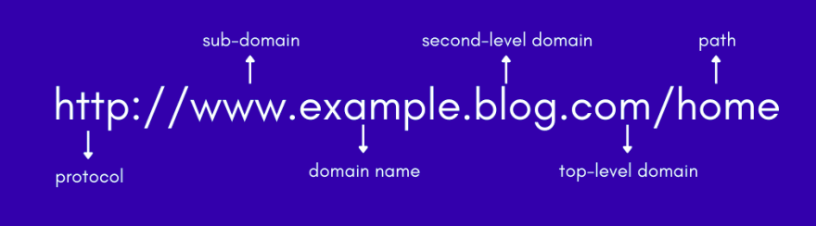

<https://www.semrush.com/blog/what-is-a-url/>

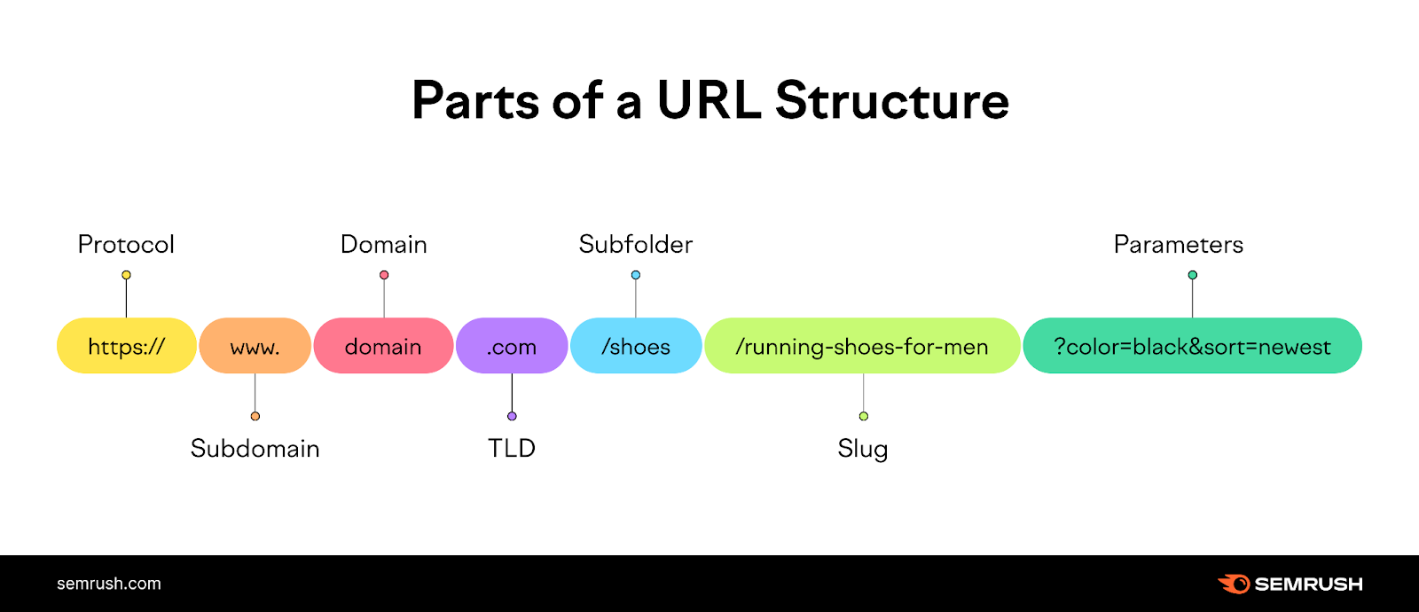

**6. Slug**



A slug is the part of a URL that identifies a specific page or a post on a website. It helps users understand the context and content of a page.

Look at this URL slug, for example: “/best-baby-shampoos/”

Reading this slug alone, users can get an idea of what the page is about.

But sometimes, you’ll also come across URL slugs that read like this: “/785321/”

Slugs with numbers are confusing to users.

The primary goal of the URL slug is to describe the content of a page. So when you create a slug, make sure it’s descriptive.

**7. URL Parameters**



URL parameters (or query strings) are part of a URL that comes after a question mark (?).

They’re composed of keys and values, separated by an equal sign (=).

The **key** tells you what kind of information is being passed. The **value** is the actual information being passed.

Let’s look at an example.

In the URL below, “color” is the key and “blue” is the value. This parameter will apply a filter to a webpage to display only blue products.

You can add multiple parameters to a URL by separating them with an ampersand (&).

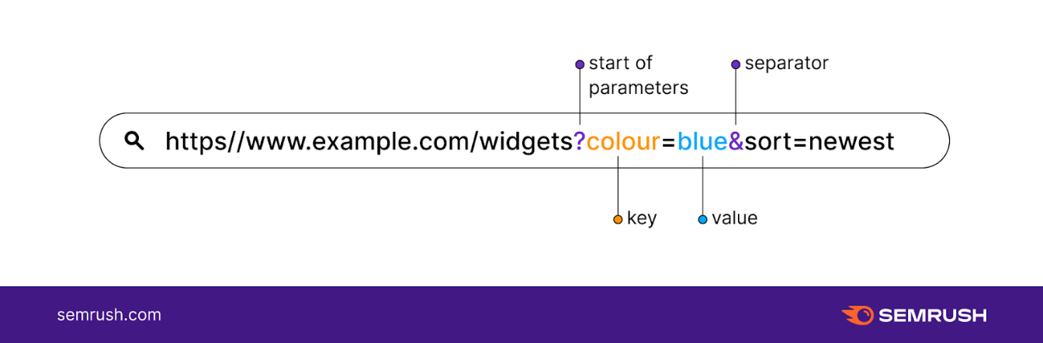

Now, there are two parameters: “color” with the value “blue” & “sort” with the value “newest”

This applies a filter to a webpage to show blue products and sorts them by the newest first.

Parameters serve multiple use cases:

* **Searching** parameters allow you to search results from a website’s internal search engine
* **Filtering** parameters let you sort and filter listings on category pages. Listings will often be products, jobs, hotels, flights, etc. And they can be filtered by various attributes, like price, availability, size, brand, salary, location, flight time, delivery time, ratings, etc.
* **Tracking** parameters help you track traffic from your ads and marketing campaigns
* **Paginating** parameters are helpful in organizing blog archive pages and forum threads in a series of pages

For more information about parameters and how to use them on your website, read our full guide to [URL parameters](https://www.semrush.com/blog/url-parameters/)